# IBM Cloud - Create a New Account[¶](https://ibm.github.io/ddc-cloud-native-security-labs/lab-00/NEWACCOUNT/#ibm-cloud-create-a-new-account)

To create a new account, follow the steps below,

1. You need an IBM Cloud account to access your cluster,
2. If you do not have an IBM Cloud account yet, go to <https://cloud.ibm.com/registration> to register,
3. In the Create an account window, enter your email and password,

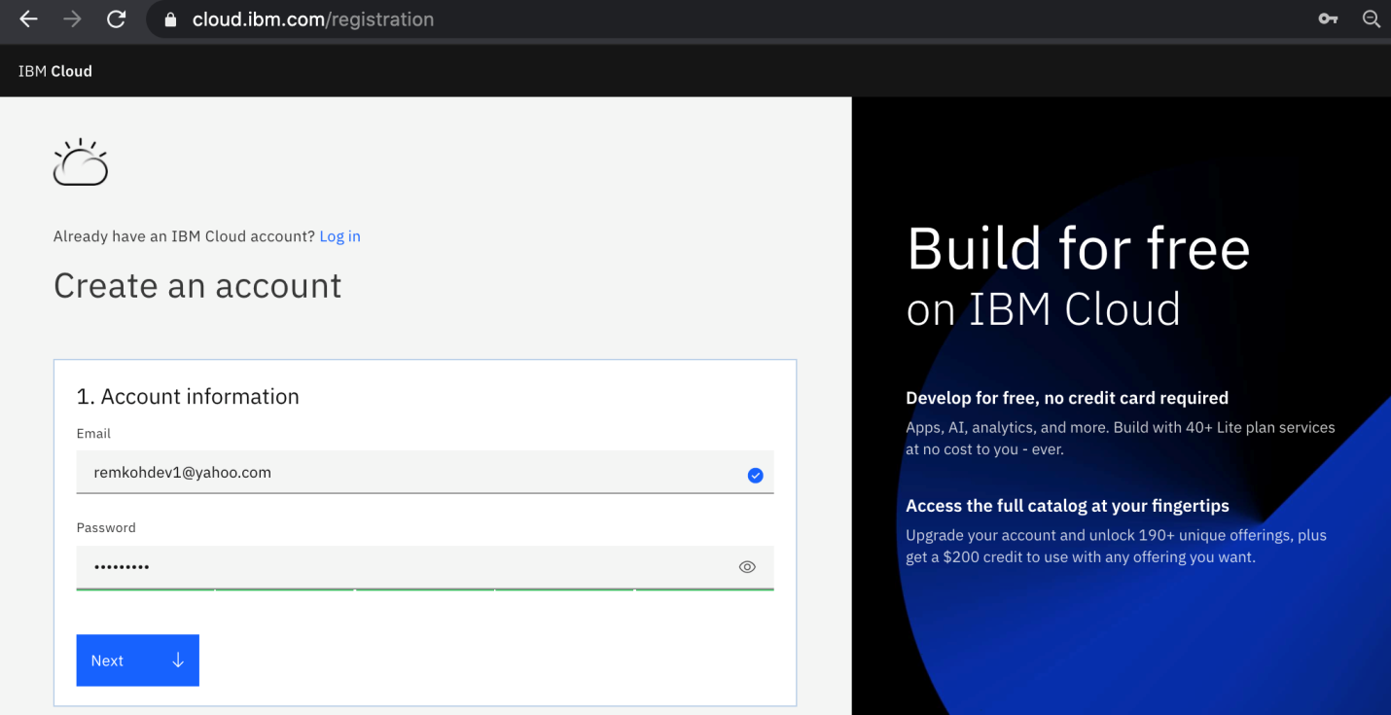

4.The Verify email section will inform you that a verification code was sent to your email,

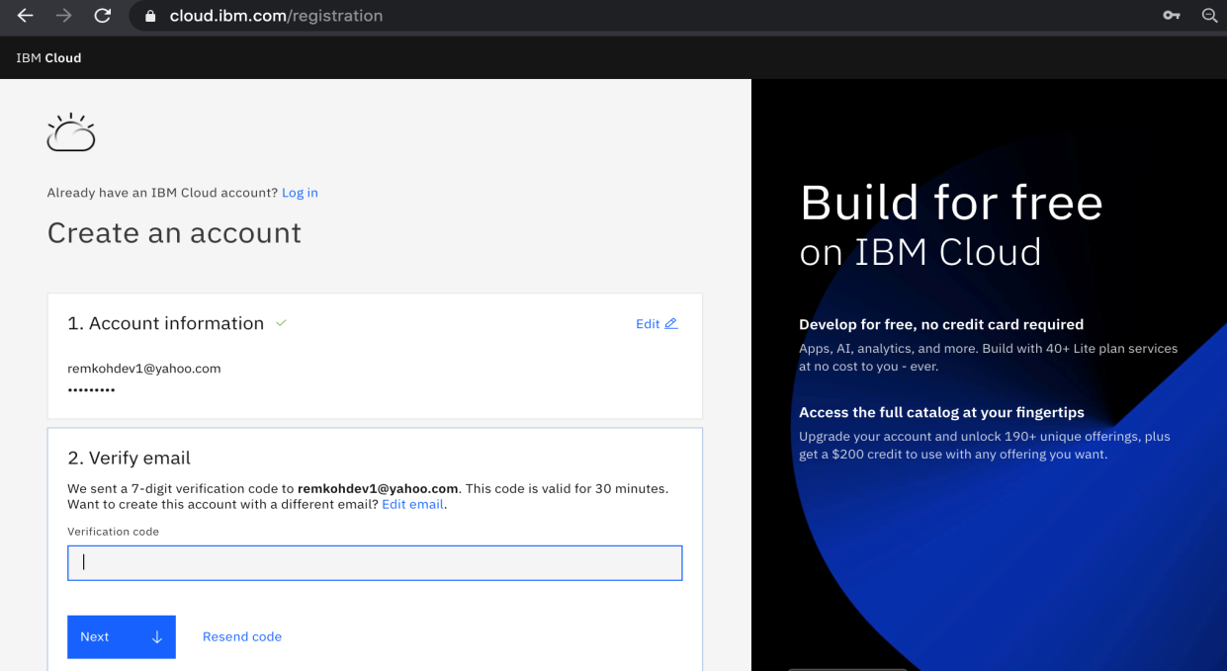

1. Switch to your email provider to retrieve the verification code,

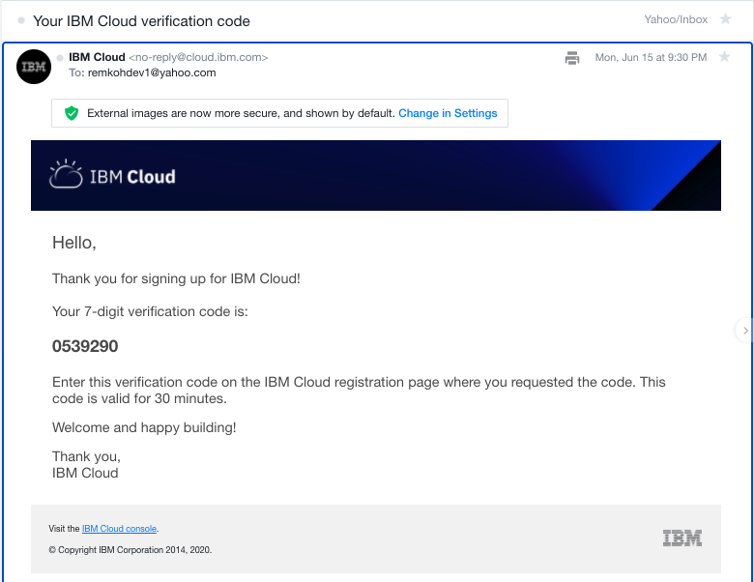

1. Enter the verification code in the Verify email section, and click Next,

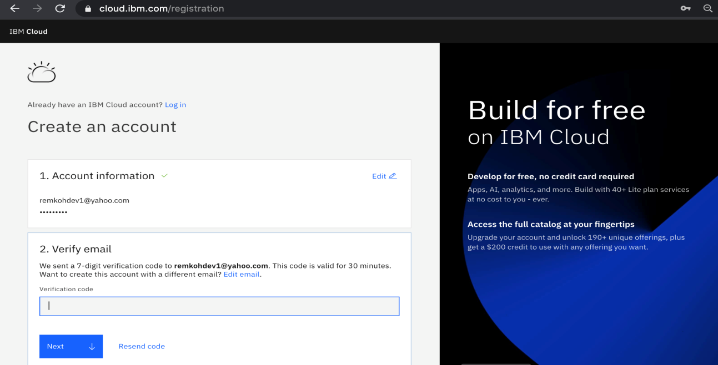

1. Enter your first name, last name and country in the Personal information section and click Next

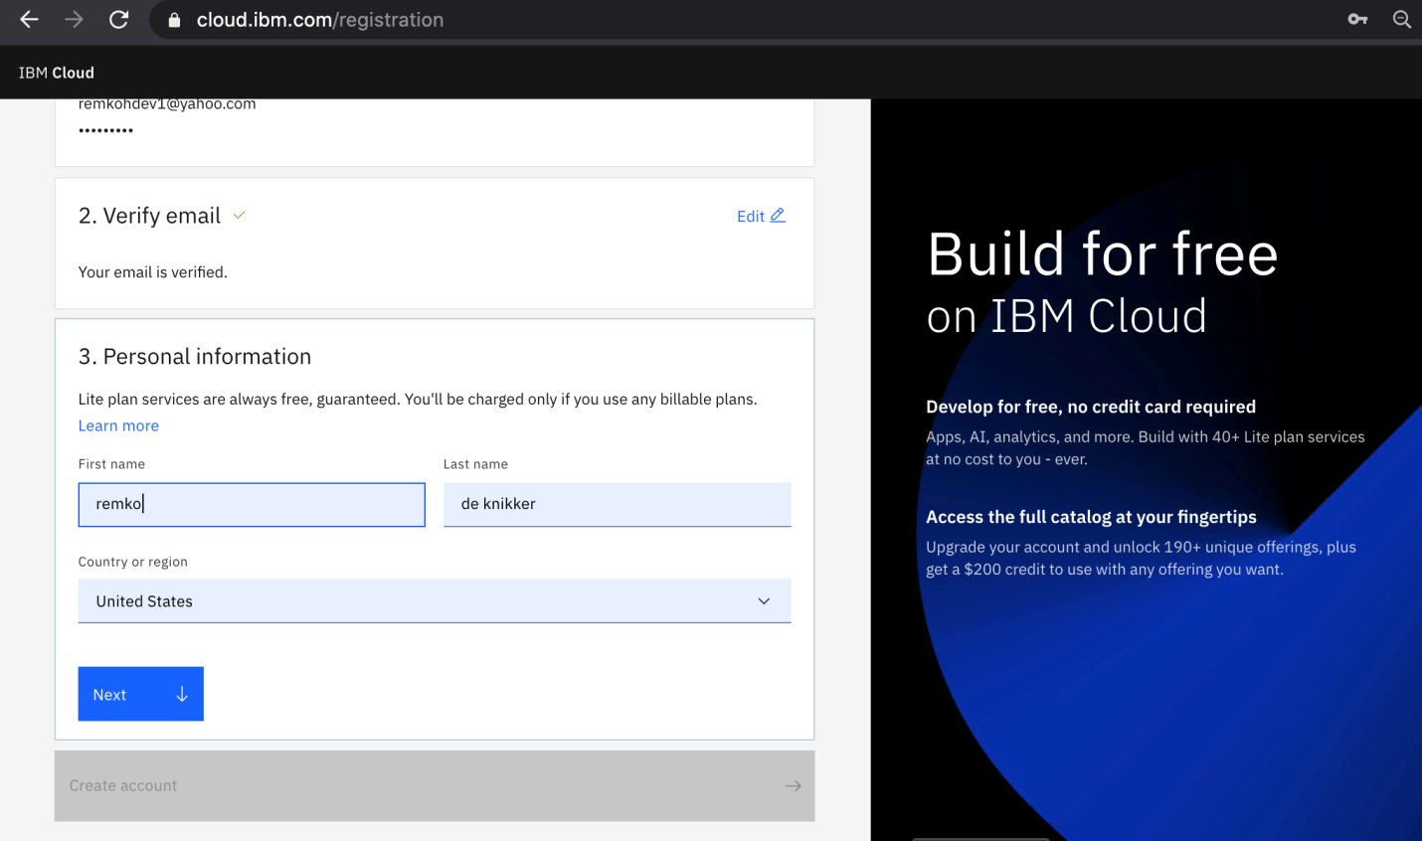8. Click Create account

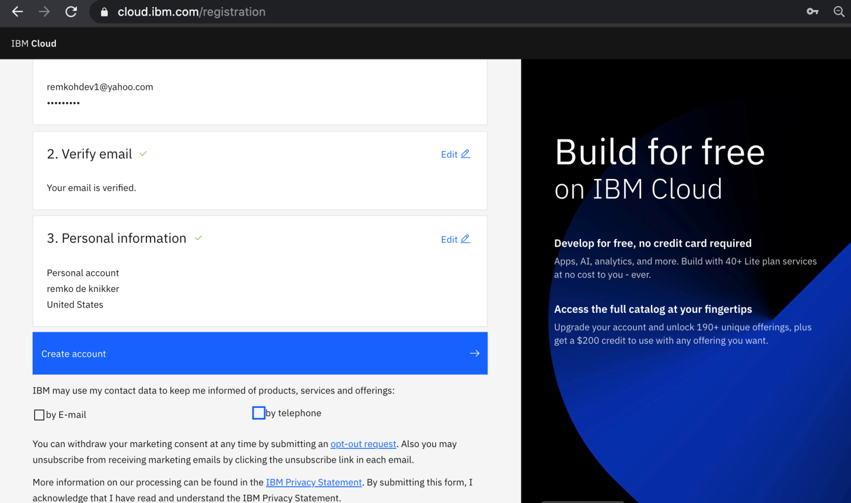

1. Your account is being created,

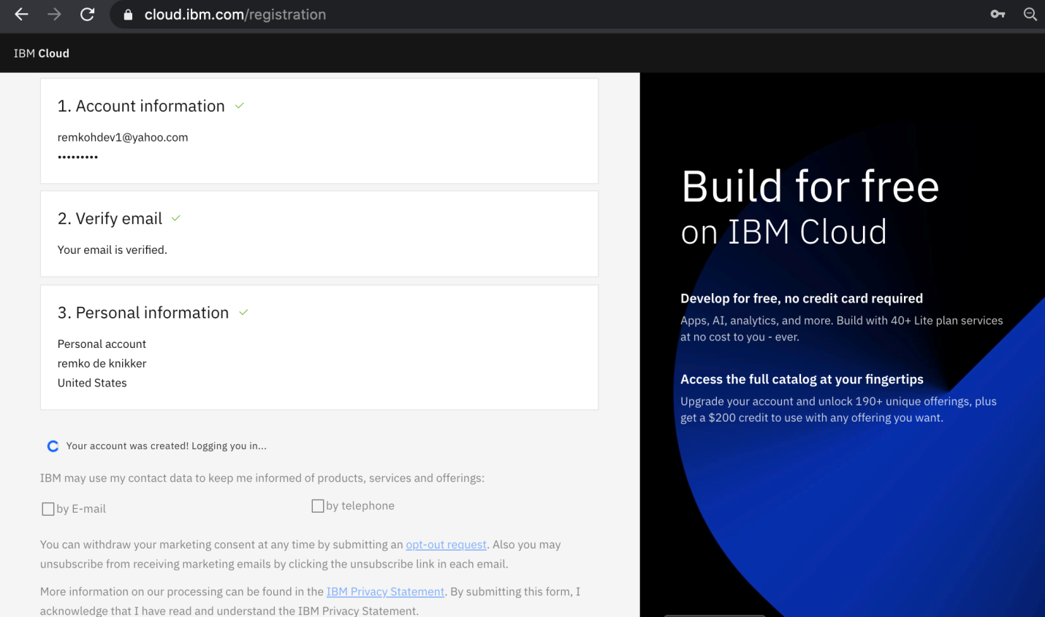

1. Review the IBM Privacy Statement

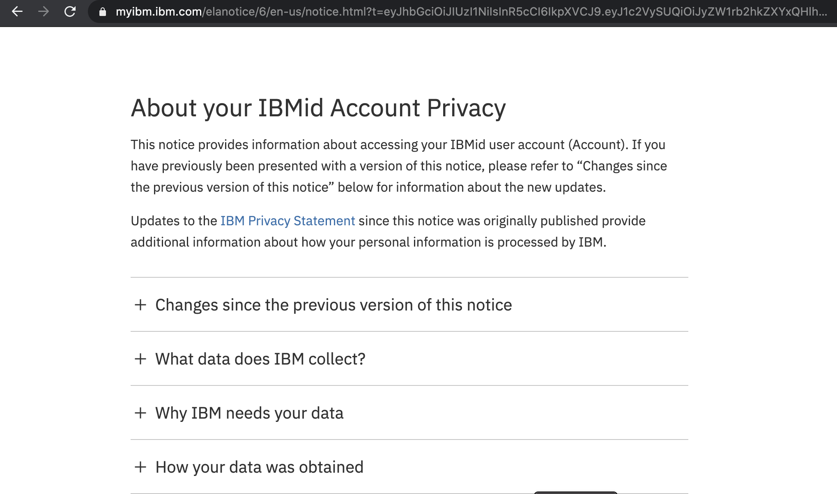

1. Click Proceed to acknowledge the privacy statement,

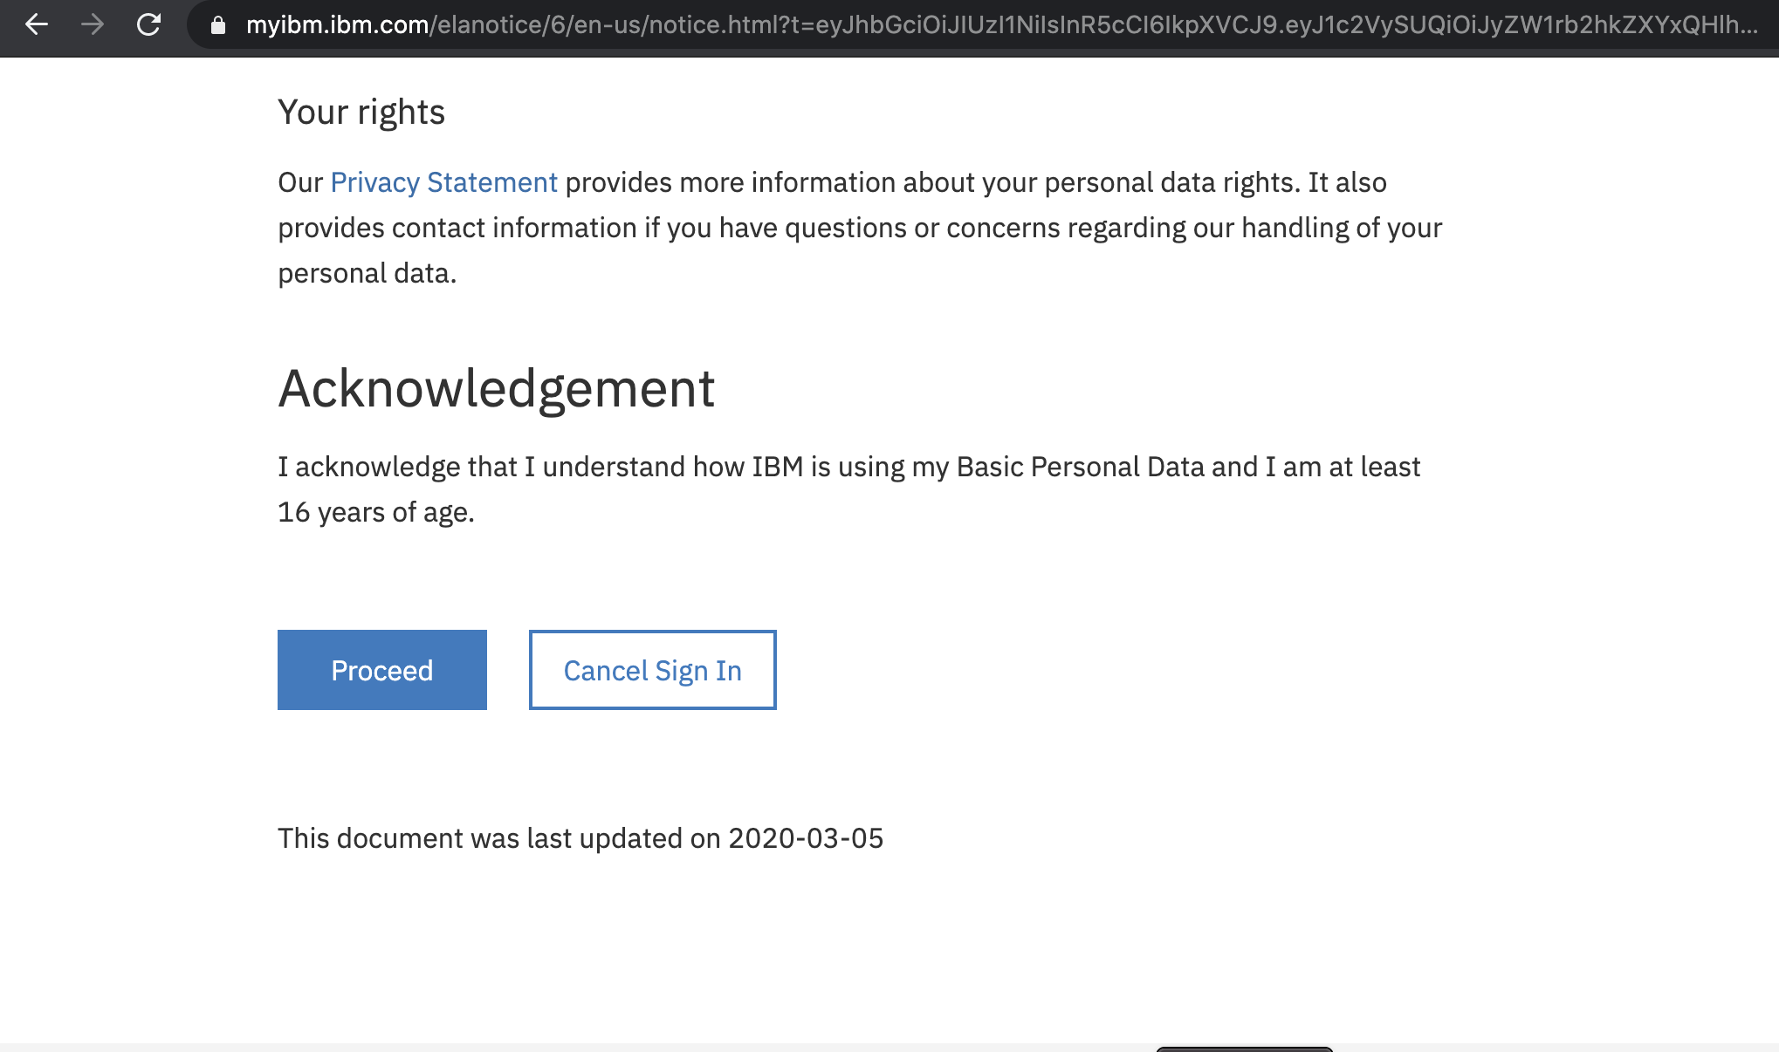

1. Switch to your email provider to review the Welcome to IBM Cloud email, and click the Login link,

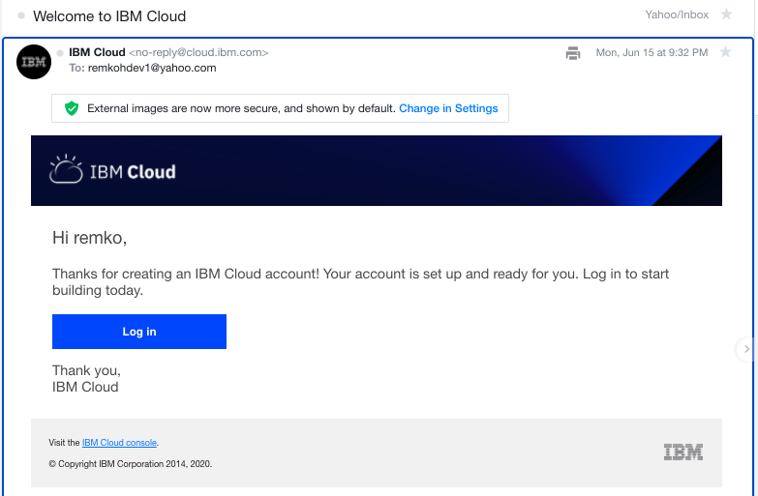

1. Enter your IBM Id to login,

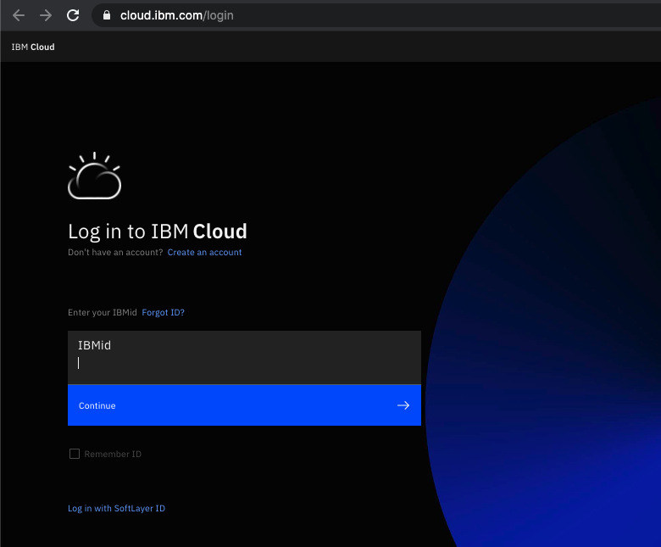

1. Enter your password to login,

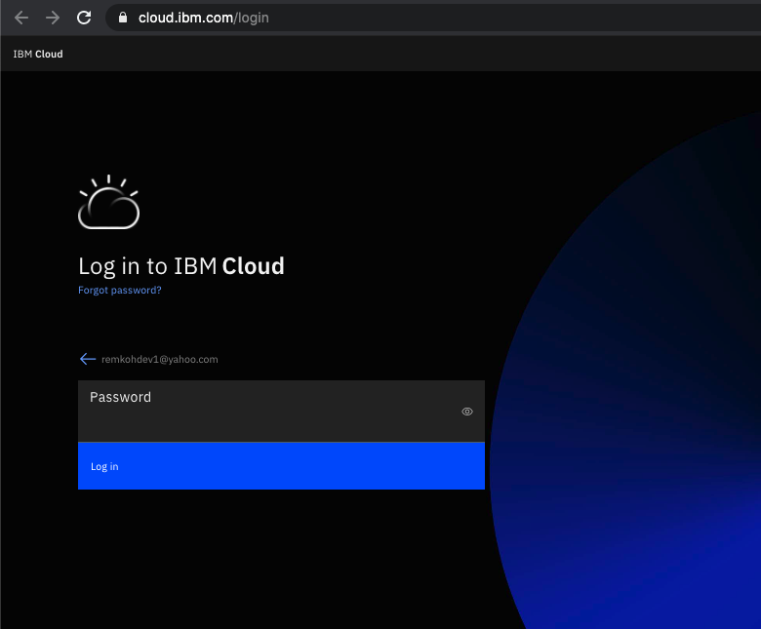

1 5. The IBM Cloud dashboard page should load,

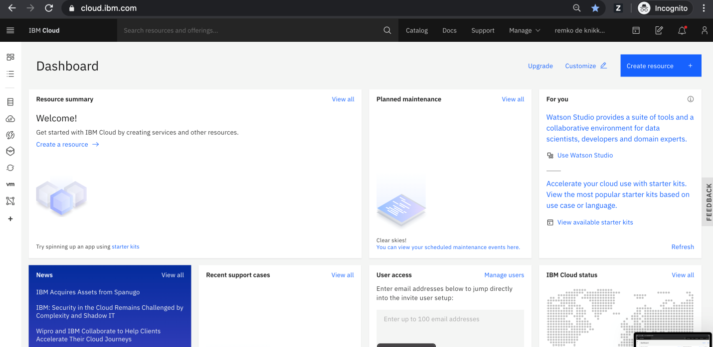

16. You have successfully registered a new IBM Cloud account.